**Project ID :**

TMP-23-226

1. Topic (12 words max)

A Novel Approach for Personalized Mobile Patient Guidance System using Artificial Intelligence

1. Research group the project belongs to

**Computing for Inclusive and Equitable Society (CIEC)**

1. Research area the project belongs to

**Bio-Medical and Health Informatics (HI)**

1. If a continuation of a previous project:

|  |  |
| --- | --- |
| Project ID |  |
| Year |  |

1. Team member details

|  |  |  |
| --- | --- | --- |
| Student Name | Student ID | Specialization |
| Udayantha Yapa Y.M. S | IT20045708 | SE |
| Dissanayaka D.M.R. A | IT20264048 | SE |
| Herath H.M.T. P | IT20276850 | SE |
| Peiris B.M. G | IT20147396 | IT |

1. Brief description of the research problem including references (200 – 500 words max) – references not included in word count

The study question for a personalized automated health guidance system for people with metabolic syndrome might be to determine how well such a system performs in managing the condition and enhancing health outcomes for people with metabolic syndrome.

The risk of heart disease, stroke, non-alcoholic fatty liver disease, peripheral vascular disorders, MI, and type 2 diabetes is increased by a combination of symptoms known as metabolic syndrome. Excessive blood pressure, high blood sugar, extra body fat around the waist/BMI, and high cholesterol or triglyceride levels are frequently symptoms of the disorder. Medication and lifestyle modifications, such as dietary and activity changes, are part of the traditional care of metabolic syndrome. For many people, however, maintaining adherence to these interventions can be challenging.

The goal of the study is to determine whether using an automated, personalized health guidance system can help people manage their metabolic syndrome by giving them the information and support they need to achieve better health outcomes. In terms of adherence to lifestyle changes, changes in vital signs, a decrease in the risk of complications, and an improvement in quality of life, the research would look at how effective the system is.

The goal of the study is to assess how well the personalized automated health guidance system performs in helping people with metabolic syndrome manage and improve their condition while also receiving personalized, real-time, and evidence-based support.

references

[1]Informatics and machine learning methods for health applications: [https://bmcmedinformdecismak.biomedcentral.com/articles/10.1186/s12911-020-01318-4Precision Nutrition: A](https://bmcmedinformdecismak.biomedcentral.com/articles/10.1186/s12911-020-01318-4Precision%20Nutrition:%20A%20) Review of [2]Personalized Nutritional Approaches for the Prevention and Management of Metabolic Syndrome: <https://www.mdpi.com/2072-6643/9/8/913>

[3]Machine Learning to Predict the Progression of Bone Mass Loss Associated with Personal Characteristics and a Metabolic Syndrome Scoring Index: https://www.mdpi.com/2227-9032/9/8/948

[4]Diagnosis of Metabolic Syndrome using Machine Learning, Statistical and Risk Quantification Techniques: A Systematic Literature Review: <https://www.medrxiv.org/content/10.1101/2020.06.01.20119339v1>

[5] Application of Artificial Intelligence in the Establishment of an Association Model between Metabolic Syndrome, TCM Constitution, and the Guidance of Medicated Diet Care: <https://www.hindawi.com/journals/ecam/2021/5530717/>

[6] Metabolic syndrome screening in adolescents: new scores AI_METS based on artificial intelligence techniques: <https://www.sciencedirect.com/science/article/abs/pii/S0939475322003349>

[7] Metabolic syndrome: <https://www.sciencedirect.com/science/article/abs/pii/S1357303910002616>

[8] A comprehensive definition for metabolic syndrome: <https://journals.biologists.com/dmm/article/2/5-6/231/2213/A-comprehensive-definition-for-metabolic-syndrome>

1. Brief description of the nature of the solution including a conceptual diagram (250 words max)

The proposed solution for the personalized automated health guidance system for metabolic syndrome is to use advanced technology to create a comprehensive health profile of individuals. The system integrates various data sources such as personal health information, medical history, and lab results to provide personalized guidance on diet, physical activity, and medications. Real-time monitoring of vital signs, such as blood pressure, blood sugar levels, and body weight, helps identify potential health issues early. The system is also integrated with mobile apps to collect real-time data on physical activity and dietary habits, providing real-time feedback and support to individuals. Interactive educational modules and resources are provided to help individuals understand their condition and manage it effectively. Telemedicine integration allows for remote consultations with healthcare providers, making it useful for individuals in remote or underserved areas. The effectiveness of the system will be evaluated through a randomized controlled trial, and the results could inform the development of similar systems for other chronic conditions and improve the care of individuals with metabolic syndrome.

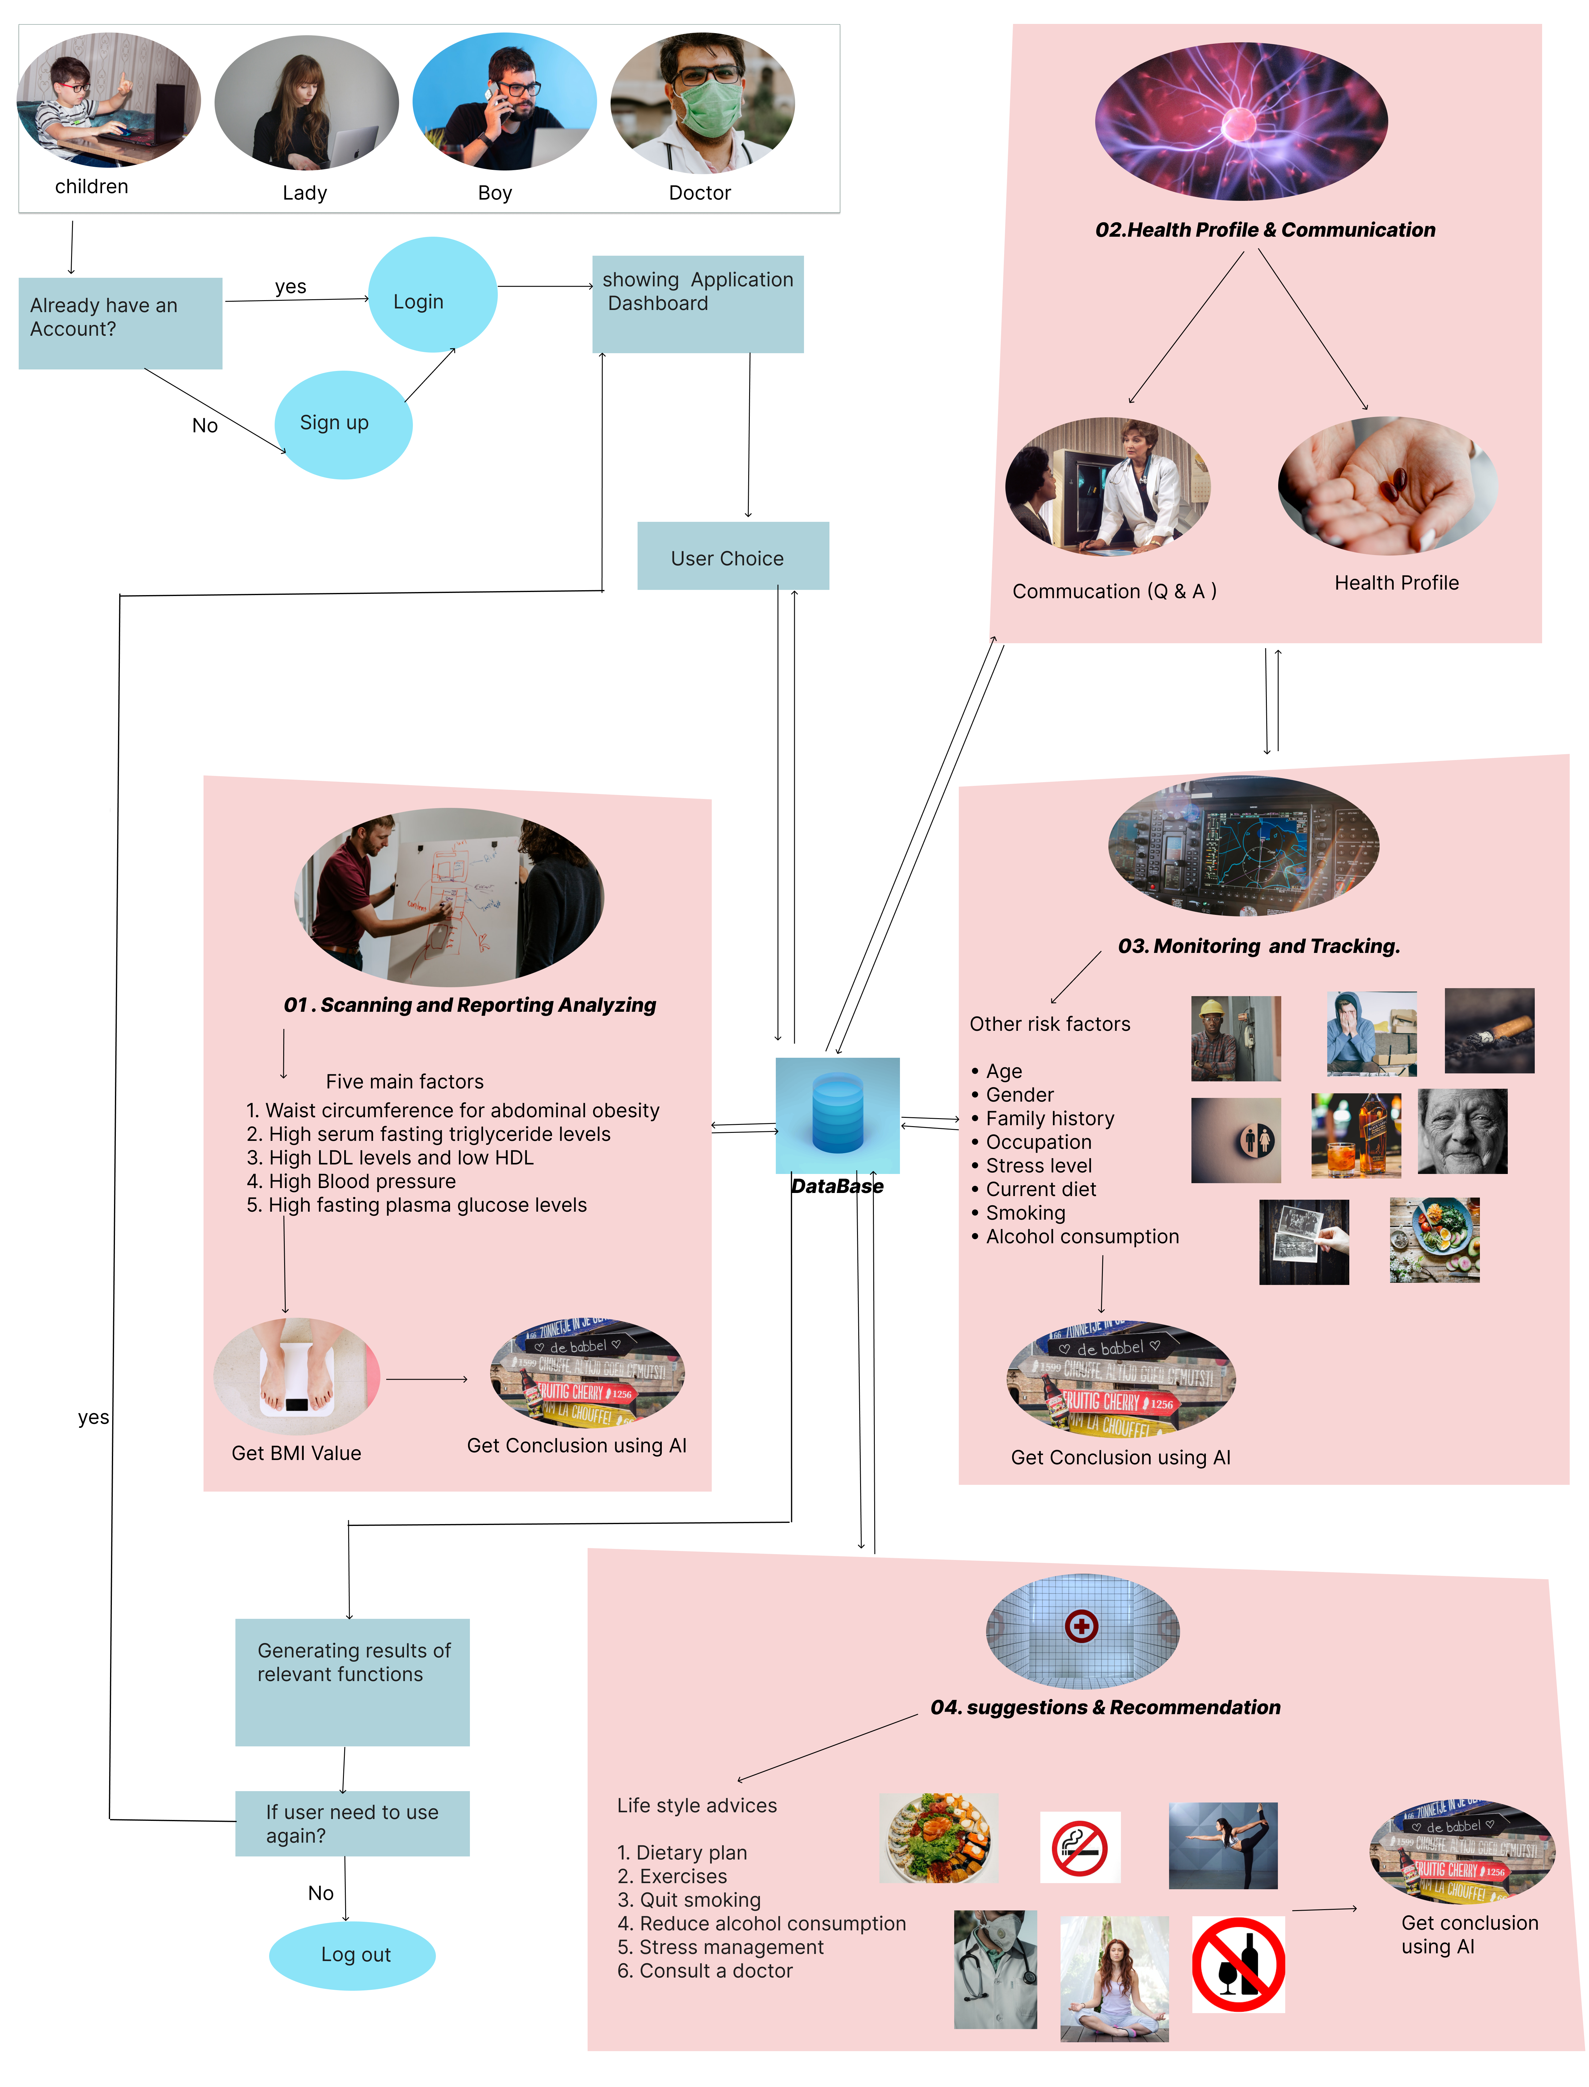

1. Brief description of specialized domain expertise, knowledge, and data requirements (300 words max)

Specialized domain expertise for a personalized automated health guidance system for metabolic syndrome requires a comprehensive understanding of the metabolic syndrome condition, including its causes, risk factors, symptoms, and available treatments.

Data requirements for the system include health information such as medical history, lab results, and vital signs, as well as information about dietary habits, physical activity levels, and medication use. This data should be collected from various sources, including electronic health records, mobile apps to create a comprehensive health profile of the individual.

To evaluate and understand the gathered data, this system's development also needs knowledge in artificial intelligence, machine learning, and data analytics. Advanced algorithms and models are needed for the system to be able to deliver customized suggestions based on the user's particular health profile. We can also get access to a lot of raw data from an online community platform for data scientists and machine learning hobbyists, including datasets for BIM, diabetes, blood pressure, and heart attack analysis and prediction.

Finally, the system should be user-friendly and accessible, with a user interface that is intuitive and easy to navigate, to encourage adoption and engagement among individuals with metabolic syndrome. This requires knowledge of human-computer interaction, user-centered design, and user experience design.

1. Objectives and Novelty

|  |  |  |  |
| --- | --- | --- | --- |
| Main Objective  The main goal of the personalized automated health guidance system for metabolic syndrome is to create a system that can give individuals with the condition individualized and targeted health advice in order to improve their general health and reduce their risk of concomitant diseases like diabetes and heart disease. To help individuals in changing their lifestyles and improve adherence to their health programs, the system will combine machine learning algorithms, customized health plans, and motivational messaging. The system will also integrate with scanning (scan reports) so that health parameters may be monitored in real-time, enhancing the efficacy of the advice given. The project's ultimate goal is to increase the health of those who have metabolic syndrome and reduce the total impact that this disorder takes on society. | | | |
| Member Name | Sub Objective | Tasks | Novelty |
| Herath H.M.T. P | Implement a system that provides individualized diet and exercise plans based on a person's medical history, level of physical activity, and dietary habits. | **Handling Health profile/plan and communication**: This component would include all relevant information about the patient, including medical history, vital signs, lifestyle habits, medication regimen, and treatment plan. The system would use this information to personalize recommendations for managing metabolic syndrome.  The system would also use natural language processing (NLP) for the communication between the patients and the system, for example through a chatbot. The chatbot could provide patients with information about their condition, answer questions, and provide guidance on managing the condition. | Implement a system that offers specialized food and exercise regimens depending on an individual's medical background, degree of physical activity, and eating preferences. All pertinent patient data, such as medical history, vital signs, dietary habits, medication schedule, and treatment plan, would be included in this component. This data would be used by the algorithm to customize management suggestions for metabolic syndrome. Natural language processing (NLP) would also be used by the system to facilitate communication between the patients and the system, maybe through a chatbot. Patients might get information about their ailment from the chatbot, get questions answered, and get advice on how to manage it. Automate the management suggestions and ideas provided by the algorithm and input them into an electronic medical record. This would be done by way of an alert sent to a physician, who would then automatically view the patient's profile on their electronic medical record. |
| Peiris B.M. G | Using goal-setting tools and tracking technologies, offer individualized advice on exercise and diet. To encourage adherence to the health plan, provide daily reminders and inspirational messages**.** | **Suggestion/recommendation**: Based on the analysis of patient data, the system would provide personalized recommendations for managing metabolic syndrome. These could include diet and exercise plans, medication regimens, and other lifestyle changes. The system would also be able to adapt and improve its recommendations over time as more data is collected and analyzed.  Additionally, the system would use notifications and reminders to help patients stay on track with their treatment plans and to remind them to take their medication. | Provide specialized guidance on fitness and diet using goal-setting tools and tracking technology. Provide frequent reminders and motivating messages to promote adherence to the health plan. The system would offer individualized suggestions for controlling metabolic syndrome based on the analysis of patient data. These could include of exercise and nutrition routines, medication schedules, and other lifestyle modifications. As additional data is gathered and processed over time, the system will be able to modify and enhance its suggestions. The system would also employ notifications and reminders to assist patients in adhering to their treatment regimens and to remind them to take their prescribed medications. The system would employ notifications and reminders to assist patients in adhering to their treatment regimens and to remind them to take their prescribed medications |
| Dissanayaka D.M.R. A | Monitor the individual's progress and adjust the health plan accordingly to ensure optimal results. | **Monitoring and tracking**: This component of the personalized automated health guidance system for metabolic syndrome would involve continuously collecting and storing data on various health metrics such as weight, blood pressure, blood sugar levels, and cholesterol levels. The system would also use tracking and visualization tools to help patients monitor their progress over time and see the effects of their treatment and uses various algorithms and techniques to analyze the collected data and assess the patient's risk of developing metabolic syndrome. This may include identifying trends and patterns, as well as predicting potential health outcomes. | This app can provide patients with self-management tools manage their metabolic syndrome.  The constant collection and storage of data on numerous health metrics, such as weight, blood pressure, blood sugar levels, and cholesterol levels, would be required for this part of the individualized automated health guidance system for metabolic syndrome. Along with using tracking and visualization tools to assist patients follow their development over time and observe the results of their therapy, the system analyzes the gathered data using a variety of algorithms and methodologies to determine the patient's risk of developing metabolic syndrome. This could entail seeing patterns and trends as well as making future health projections. |
| Udayantha Yapa Y.M. S | Examining medical records to track and monitor health metrics like blood pressure, blood sugar levels, fasting triglyceride levels, cholesterol levels, and steps taken in real-Time. | **management of Report analysis/scanning**: The system would use advanced algorithms and machine learning techniques to analyze patient data and identify patterns and trends by scanning medical report. This would allow the system to provide more accurate and effective recommendations for managing the condition and update patient profile according to the patient's current status. | The system will monitor health indicators including blood pressure, blood sugar levels, fasting triglyceride levels, cholesterol levels and actions taken in real-time by analyzing patient data using sophisticated algorithms and machine learning techniques as well as viewing medical records. Examining medical records for trends. As a result, the system can update the patient profile to reflect the patient's current condition and make more accurate and useful recommendations for disease management. The system is also able to recommend personalized treatment plans based on the patient's age, gender, weight history and other relevant data. In addition, the system can provide a list of recommended interventions with explanations for each choice and an overview of potential risks. This new solution is expected to reduce healthcare costs by providing more precise and accurate medical advice to a doctor or nurse. To help patients manage their condition efficiently, it should be done manually. |

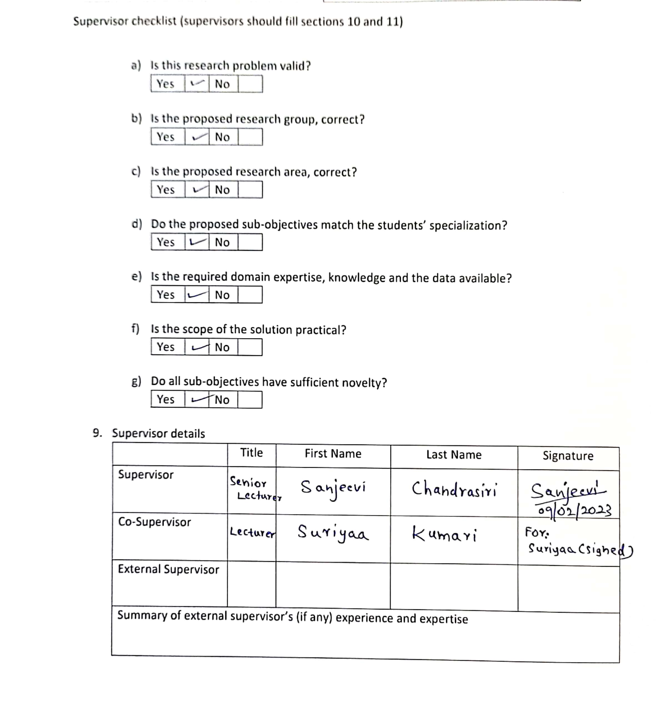

# Summary Sheet

***The topic evaluation panel will use the summary sheet to evaluate the suitability of the project***

1. Brief description of research problem including references (200 – 300 words max)

The study question for a personalized automated health guidance system for people with metabolic syndrome might be to determine how well such a system performs in managing the condition and enhancing health outcomes for people with metabolic syndrome.

The risk of heart disease, stroke, non-alcoholic fatty liver disease, peripheral vascular disorders, MI, and type 2 diabetes is increased by a combination of symptoms known as metabolic syndrome. Excessive blood pressure, high blood sugar, extra body fat around the waist/BMI, and high cholesterol or triglyceride levels are frequently symptoms of the disorder. Medication and lifestyle modifications, such as dietary and activity changes, are part of the traditional care of metabolic syndrome. For many people, however, maintaining adherence to these interventions can be challenging.

The goal of the study is to determine whether using an automated, personalized health guidance system can help people manage their metabolic syndrome by giving them the information and support they need to achieve better health outcomes. In terms of adherence to lifestyle changes, changes in vital signs, a decrease in the risk of complications, and an improvement in quality of life, the research would look at how effective the system is.

The goal of the study is to assess how well the personalized automated health guidance system performs in helping people with metabolic syndrome manage and improve their condition while also receiving personalized, real-time, and evidence-based support.

references

[1]Informatics and machine learning methods for health applications: [https://bmcmedinformdecismak.biomedcentral.com/articles/10.1186/s12911-020-01318-4Precision Nutrition: A](https://bmcmedinformdecismak.biomedcentral.com/articles/10.1186/s12911-020-01318-4Precision%20Nutrition:%20A%20) Review of [2]Personalized Nutritional Approaches for the Prevention and Management of Metabolic Syndrome: <https://www.mdpi.com/2072-6643/9/8/913>

[3]Machine Learning to Predict the Progression of Bone Mass Loss Associated with Personal Characteristics and a Metabolic Syndrome Scoring Index: https://www.mdpi.com/2227-9032/9/8/948

[4]Diagnosis of Metabolic Syndrome using Machine Learning, Statistical and Risk Quantification Techniques: A Systematic Literature Review: <https://www.medrxiv.org/content/10.1101/2020.06.01.20119339v1>

[5] Application of Artificial Intelligence in the Establishment of an Association Model between Metabolic Syndrome, TCM Constitution, and the Guidance of Medicated Diet Care: <https://www.hindawi.com/journals/ecam/2021/5530717/>

[6] Metabolic syndrome screening in adolescents: new scores AI_METS based on artificial intelligence techniques: <https://www.sciencedirect.com/science/article/abs/pii/S0939475322003349>

[7] Metabolic syndrome: <https://www.sciencedirect.com/science/article/abs/pii/S1357303910002616>

[8] A comprehensive definition for metabolic syndrome: <https://journals.biologists.com/dmm/article/2/5-6/231/2213/A-comprehensive-definition-for-metabolic-syndrome>

1. Brief description of the nature of the solution (150 words max)

The proposed solution for the personalized automated health guidance system for metabolic syndrome is to use advanced technology to create a comprehensive health profile of individuals. The system integrates various data sources such as personal health information, medical history, and lab results to provide personalized guidance on diet, physical activity, and medications. Real-time monitoring of vital signs, such as blood pressure, blood sugar levels, and body weight, helps identify potential health issues early. The system is also integrated with mobile apps to collect real-time data on physical activity and dietary habits, providing real-time feedback and support to individuals. Interactive educational modules and resources are provided to help individuals understand their condition and manage it effectively. Telemedicine integration allows for remote consultations with healthcare providers, making it useful for individuals in remote or underserved areas. The effectiveness of the system will be evaluated through a randomized controlled trial, and the results could inform the development of similar systems for other chronic conditions and improve the care of individuals with metabolic syndrome.

1. Objectives and novelty

|  |  |  |  |
| --- | --- | --- | --- |
| Main Objective  The main goal of the personalized automated health guidance system for metabolic syndrome is to create a system that can give individuals with the condition individualized and targeted health advice in order to improve their general health and reduce their risk of concomitant diseases like diabetes and heart disease. To help individuals in changing their lifestyles and improve adherence to their health programs, the system will combine machine learning algorithms, customized health plans, and motivational messaging. The system will also integrate with scanning (scan reports) so that health parameters may be monitored in real-time, enhancing the efficacy of the advice given. The project's ultimate goal is to increase the health of those who have metabolic syndrome and reduce the total impact that this disorder takes on society. | | | |
| Member Name | Sub Objective | Tasks | Novelty |
| Herath H.M.T. P | Implement a system that provides individualized diet and exercise plans based on a person's medical history, level of physical activity, and dietary habits. | **Handling Health profile/plan and communication**: This component would include all relevant information about the patient, including medical history, vital signs, lifestyle habits, medication regimen, and treatment plan. The system would use this information to personalize recommendations for managing metabolic syndrome.  The system would also use natural language processing (NLP) for the communication between the patients and the system, for example through a chatbot. The chatbot could provide patients with information about their condition, answer questions, and provide guidance on managing the condition. | Implement a system that offers specialized food and exercise regimens depending on an individual's medical background, degree of physical activity, and eating preferences. All pertinent patient data, such as medical history, vital signs, dietary habits, medication schedule, and treatment plan, would be included in this component. This data would be used by the algorithm to customize management suggestions for metabolic syndrome. Natural language processing (NLP) would also be used by the system to facilitate communication between the patients and the system, maybe through a chatbot. Patients might get information about their ailment from the chatbot, get questions answered, and get advice on how to manage it. Automate the management suggestions and ideas provided by the algorithm and input them into an electronic medical record. This would be done by way of an alert sent to a physician, who would then automatically view the patient's profile on their electronic medical record. |
| Peiris B.M. G | Using goal-setting tools and tracking technologies, offer individualized advice on exercise and diet. To encourage adherence to the health plan, provide daily reminders and inspirational messages. | **Suggestion/recommendation**: Based on the analysis of patient data, the system would provide personalized recommendations for managing metabolic syndrome. These could include diet and exercise plans, medication regimens, and other lifestyle changes. The system would also be able to adapt and improve its recommendations over time as more data is collected and analyzed.  Additionally, the system would use notifications and reminders to help patients stay on track with their treatment plans and to remind them to take their medication. | Provide specialized guidance on fitness and diet using goal-setting tools and tracking technology. Provide frequent reminders and motivating messages to promote adherence to the health plan. The system would offer individualized suggestions for controlling metabolic syndrome based on the analysis of patient data. These could include of exercise and nutrition routines, medication schedules, and other lifestyle modifications. As additional data is gathered and processed over time, the system will be able to modify and enhance its suggestions. The system would also employ notifications and reminders to assist patients in adhering to their treatment regimens and to remind them to take their prescribed medications. The system would employ notifications and reminders to assist patients in adhering to their treatment regimens and to remind them to take their prescribed medications. |
| Dissanayaka D.M.R. A | Monitor the individual's progress and adjust the health plan accordingly to ensure optimal results. | **Monitoring and tracking**: This component of the personalized automated health guidance system for metabolic syndrome would involve continuously collecting and storing data on various health metrics such as weight, blood pressure, blood sugar levels, and cholesterol levels. The system would also use tracking and visualization tools to help patients monitor their progress over time and see the effects of their treatment and uses various algorithms and techniques to analyze the collected data and assess the patient's risk of developing metabolic syndrome. This may include identifying trends and patterns, as well as predicting potential health outcomes. | This app can provide patients with self-management tools manage their metabolic syndrome.  The constant collection and storage of data on numerous health metrics, such as weight, blood pressure, blood sugar levels, and cholesterol levels, would be required for this part of the individualized automated health guidance system for metabolic syndrome. Along with using tracking and visualization tools to assist patients follow their development over time and observe the results of their therapy, the system analyzes the gathered data using a variety of algorithms and methodologies to determine the patient's risk of developing metabolic syndrome. This could entail seeing patterns and trends as well as making future health projections. |
| Udayantha Yapa Y.M. S | Examining medical records to track and monitor health metrics like blood pressure, blood sugar levels, fasting triglyceride levels, cholesterol levels, and steps taken in real-Time. | **management of Report analysis/scanning**: The system would use advanced algorithms and machine learning techniques to analyze patient data and identify patterns and trends by scanning medical report. This would allow the system to provide more accurate and effective recommendations for managing the condition and update patient profile according to the patient's current status. | The system will monitor health indicators including blood pressure, blood sugar levels, fasting triglyceride levels, cholesterol levels and actions taken in real-time by analyzing patient data using sophisticated algorithms and machine learning techniques as well as viewing medical records. Examining medical records for trends. As a result, the system can update the patient profile to reflect the patient's current condition and make more accurate and useful recommendations for disease management. The system is also able to recommend personalized treatment plans based on the patient's age, gender, weight history and other relevant data. In addition, the system can provide a list of recommended interventions with explanations for each choice and an overview of potential risks. This new solution is expected to reduce healthcare costs by providing more precise and accurate medical advice to a doctor or nurse. To help patients manage their condition efficiently, it should be done manually. |

**This part to be filled by the Topic Screening Panel members**

Acceptable: Mark/Select as necessary

|  |  |
| --- | --- |
| Topic Assessment Accepted |  |
| Topic Assessment Accepted with minor changes (should be followed up by the supervisor)* |  |
| Topic Assessment to be Resubmitted with major changes* |  |
| Topic Assessment Rejected. Topic must be changed |  |

* Detailed comments given below

Comments

The Review Panel Details

|  |  |
| --- | --- |
| **Member’s Name** | **Signature** |
|  |  |
|  |  |
|  |  |
|  |  |
|  |  |
|  |  |

**Important**:

1. According to the comments given by the panel, do the necessary modifications and get the approval by the **Supervisor** or the **Same Panel**.
2. If the project topic is rejected, identify a new topic, and request the RP Team for a new topic assessment.
3. The form approved by the panel must be attached to the **Project Charter Form**.